Supplier Actionable Notifications (SAN)

Flip your incoming PO's into invoices right from the PO email. This is the easiest way to submit electronic invoices through Coupa. You can also acknowledge and comment on PO's right from the email.
Suppliers that are reluctant to join another “network”, remember another password, and go to another website to occasionally receive a purchase order (PO) or send an invoice can transact with their Coupa customers without having to register for or log in to the Coupa Supplier Portal (CSP) or any other website.
Supplier Actionable Notifications (SAN) allow suppliers to act on POs directly from email notifications for POs created in Coupa, having the options to acknowledge, create an invoice from, or add a comment to a PO, or create a CSP account if they want to take advantage of the benefits of working with their customers through the CSP.
Suppliers also get notifications after they submit an invoice, letting them know when their customers perform an action. This improves transparency and further reduces the need for suppliers to track down the status of their invoices through phone calls or emails.
See below for how to Flip your incoming PO's into invoices right from the PO email.
Flip your incoming PO's into invoices right from the PO email.
- You will receive an email from UTHealth with your Purchase Order displayed along with the Purchase Ordered attached.
- From the email, you can Create Invoice or forward it to someone within your company to create the invoice.
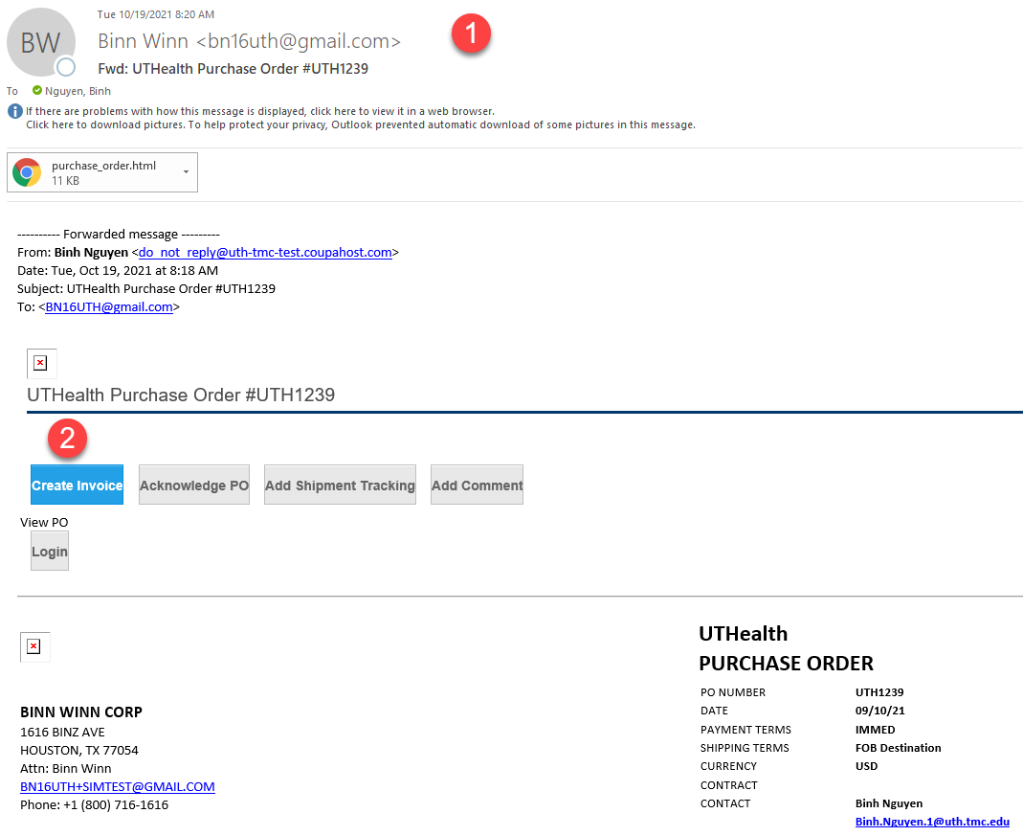
- When you click on Create Invoice, you’ll need to fill out all the mandatory fields with an asterisk (*)
  - Currency will need to be in USD.
- In the Attachments field – upload a copy of your invoice.
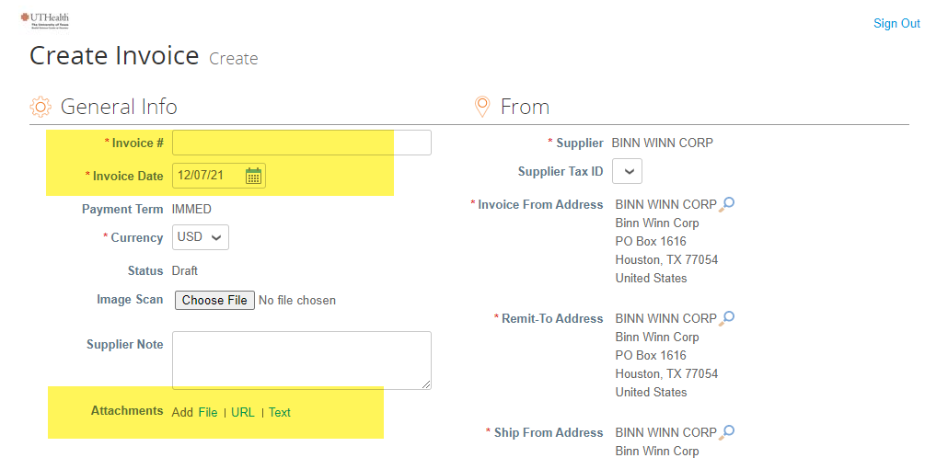
- Line Details will pull from the Purchase Order.
Hints:
  - If you are not billing for a specific line you may remove a line by using the delete line icon ().
  - Shipping and/or Handling charges, if any, can be added to the header field in the Totals & Taxes section.
  - UTHealth is a tax-exempt entity and suppliers should check with UTHealth before adding any taxes
- Comments and additional attachment can be added before submitting invoice. To add a comment, enter your comment(s) and click on “Add Comments”. Comments can be used to communicate without having to use your email application.
- Once all items have been entered, click on the “Submit” button.
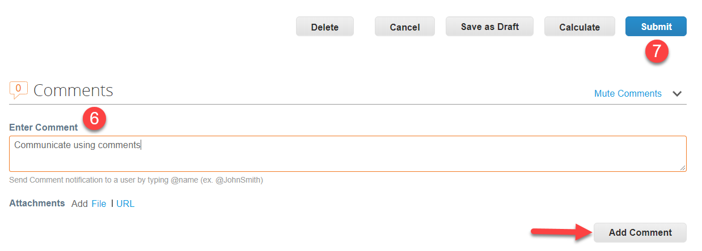
- When submitting the invoice, a box will appear confirming if you are ready to send the invoice to UTHealth along with the amount that is being sent. To send the invoice click on “Send Invoice”. To go back and edit the invoice, click on “Continue Editing”.
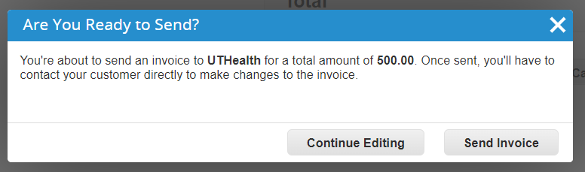
- Suppliers will receive a notification after an invoice has been submitted.

.

